Drvr User Manual

Kapil Haresh

**Shien Wee Ng**

**Dyalan Shanmugarajah**

Hui Jia Yeoh

Version Updates:

|  |  |  |  |
| --- | --- | --- | --- |
| **Version** | **Changes made by** | **Changes made** | **Date** |
| 1.0 | Hui Jia Yeoh | * Added Overview, Objectives, Installation (incomplete). * Inserted Infographics, Simulation, Quiz section. Images used were mock ups done by Kapil. * Infographics guide added but with no suitable screens to add. The same thing goes for quiz | 30-4-2015 |
| 2.0 | Hui Jia Yeoh | * Updated Infographics and Quiz content according to the meeting held on 1-5-2015. * Added version updates section to keep track of changes made when, where and by whom. | 2-5-2015 |
| 3.0 | Hui Jia Yeoh | * Updated simulation section * Added components based on Shien Wee’s use case and Kapil’s functionality description. * Added some icon description (icons that will be used in the program)   Icon credits: Icon made by [Freepik](http://www.freepik.com/) from www.flaticon.com | 14-5-2015 |
|  |  |  |  |

# **Overview**

Ever wondered how much you know about your car and how it works on the inside? Let Drvr take you through an immersive learning experience to further develop your knowledge on the four wheel automobile you have been or will be driving!

Drvr’s three components will take you on a drive on the learning lane, allowing you to experience informative infographics, interactive systems simulation and challenging quizzes to enhance your understanding on how a car works.

# **Objectives**

Drvr has the following objectives:

* To produce informed users by polishing/improving their knowledge on cars
* To allow users to understand how the components in the car interact.
* To allow users to put the knowledge they have acquired to test.

# **Installation**

* Run the setup file that comes with this manual.
* [Include images to allow user to follow instructions]

# **Introducing Drvr**

[Insert Drvr main menu here]

## **Learning with Infographics**

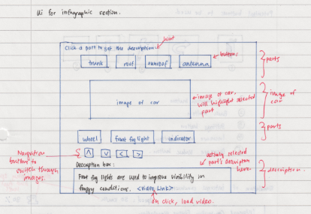Choosing the Infographics option from the main menu will bring you to a screen as shown in figure 1. The infographics will allow you to learn through brief descriptions, highlighted parts of the car and video links.

Figure 1: Infographics main screen

### VIEW

* You will be able to see different parts and views of the car by clicking on either the left or right arrow that cycles through the ‘Front’, ‘Rear’, ‘Side’, ‘Top and ‘Interior’ view of the car.
* Choosing the up or down arrow will take you to a zoomed in or out perspective of the car of the view you have chosen.



Switch to next view

Switch to previous view

Zoom out

Zoom in

### COMPONENTS LIST

* You will be able to select any component listed in this list to learn more about it.
* Description of the part can be found in the description box below the image.
* The component that you have selected will be highlighted on the car.
* In addition, you will also be able to click on any part of the car to learn more about it. The description of the part will be shown in the description box below the image and the respective component name will be highlighted.

### DESCRIPTION BOX

* The description of the selected part will be appear here.
* Besides that, there will be a button that links to a YouTube video for some parts to further describe the selected component. A pop up window will appear for this video to play as shown in figure [x].

## MISCELLANEOUS

Other buttons used in this part of the program:

Return to Main Menu/Previous Screen



## **Understanding with Simulation**

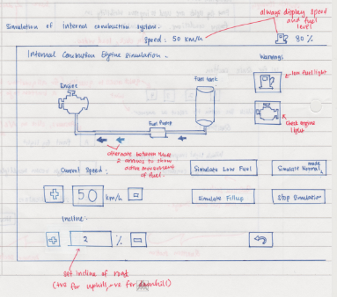Choosing simulation will take you to a screen which looks as shown in figure[x]. The dashboard above will remain, allowing you to see what happens when certain circumstances occur- lighting up specific symbols and showing the present speed of your car. In addition, certain components on the instrument cluster will light up when situations such as low fuel or high temperature occurs.

Return to Main Menu/Previous Screen

Increment Value

Decrement Value



There is a total of 9 selectable systems and situations which you can view while the simulation is running:

1. Wheel Drive System
2. Fuel System
3. Cooling System
4. Electrical System
5. Steering System
6. Adding Attachment
7. Alternative Fuel Powered Drivetrains
8. High Altitude Driving

You can start the engine by clicking the ‘START’ engine button and adjust the speed of the car accordingly. A digital speedometer will be displayed for you to keep track of your car’s speed in addition to your car’s fuel level and temperature. (REMEMBER: Your car won’t be moving at 0 km/h, so you will have to increase its speed). You can also adjust the inclination of the road your car is driving on to observe the relationship between inclination and fuel consumption.

Choosing a system or situation will bring up a side panel which shows you how the system works while the simulation is running. An example of the fuel system selected is shown below: [insert fuel panel appearance here]

## Wheel Drive System

When the wheel drive system is selected, the following will be shown:

[insert wheel drive start screen].

You are able to choose between the front wheel drive, rear wheel drive and all-wheel drive mode but do ensure that you remember to stop your car and make sure you start the car engine again to watch the simulation of the drive mode you have selected!

## Fuel System

Selecting to view the fuel system will allow you to simulate what happens to the system when the car is:

1. On low fuel
2. Filled with incorrect fuel (Accessed via the Simulate Filling button)
3. In Normal mode
4. On an inclined road

[insert fuel system view]

## Cooling System

The cooling system will show you how the car keeps its engine cool and what happens when it overheats. You will be able to choose between two conditions:

1. High temperature (Overheat)
2. Normal temperature

[insert cooling system view]

## Electrical System

Selecting to view the Electrical System from the Simulation menu will bring you to this screen:

[insert electrical system view].

You can choose to view any of these sub-systems under the electrical system:

### Lights

Selecting to view the light components will allow you to choose between viewing how power is transmitted from the battery to the:

1. Headlights
2. Front Fog Lights
3. High Beam
4. Rear Fog Lights
5. Hazard Lights

[insert example of one of the components turned on]

### Wipers

Turning on the wipers will allow you to simulate how the wipers get its power. You will also be able to adjust the speed of the wiper from 1 to 3.

### Audio

Choosing to turn the audio on will show you how power is transmitter to the audio system. You will be able to adjust the volume of the audio as well as the radio channels.

### Cruise Control

The cruise control mode will be simulated when chosen and you will be able to adjust the speed of the cruise. Make sure you don’t leave your speed at 0 or your car will not move!

### Defrost Rear

You can simulate the activation of the rear heater of the car and where power is transmitted to by choosing this option.

## Steering System

The steering system will show you what happens when you turn the steering wheel and the limit of a car’s turn. By clicking left or right, the car will turn in the direction selected.

[Include image of steering system]

## Braking System

There will be two components which you can trigger in when viewing the simulation under the braking system, namely:

### Hand Break

Activating the hand break will light the hand brake icon on the dashboard.

### Foot Break

Holding the foot brake button will slow the car down at a fixed rate. Releasing will stop the reduction of speed.

## Adding Attachment

You can simulate what happens when you add an attachment to the car. The following are attachments which you can add to the car:

1. Trailer
2. Tow Box

You can also unmount the attachment whenever required.

## Alternate Fuel Powered Drivetrains

This mode will simulate the car running on alternative fuel, namely:

1. Hybrid
2. Hydrogen
3. Electric

Each mode will describe how the car operates on these fuel to provide energy to the engine/motor.

## High Altitude Driving

This simulation will show how driving on differing altitudes affect fuel consumption. You will be able to see the rate at how fuel is burnt against the altitude by adjusting the altitude of the car.

[insert image]

In addition to being able to test systems separately, you will also be able to view the status of the other components of the car under ‘Thread Monitor’.

If some terms are different in your region, you can choose to ‘Change Region’ (i.e. from United Kingdom to United States) to better suit your understanding.

## **Test yourself with the Quiz**

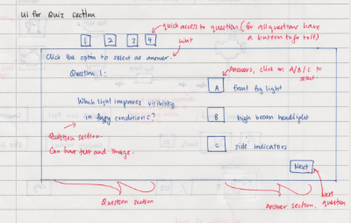The quiz segment will test you on how well you have understood the car systems from the infographics and simulation part. Selecting the option to take the quiz will take you to a page containing the quiz instructions as shown below: [Insert image of quiz instruction page]

Figure 3: An example of the quiz question

## During the quiz

* A series of questions will be provided to you and you will be required to answer them within 10 minutes.
* The segment on the left will be where the question will be while the segment on the right will be where the answers are, as shown in Figure 3.
* Answers can be selected using the keyboard in accordance to the number for the question (e.g. pressing ‘1’ for answer ‘1’). Pressing ‘Enter’ will submit that answer for the question and will move on to the next question.
* Questions can be in the form of text or image and you will be required to select the most befitting answer from the answer section.
* You are free to answer the questions in any particular order and can access questions quickly from the quick access bar above the question.
* You are allowed to abort the quiz midway but no statistics will be recorded and upon starting the quiz again, you will have to begin from the start once more.

## Results

* After all questions have been answered, a final page showing you the summary of your progress through the quiz, including number of questions answered and unanswered.
* You will then obtain your results after registering your confirmed answers as shown in the figure below: [WARNING: You will not be able to change your answer after submitting your answers after this page].

**[Insert end page image]**

* You are able to review the questions that you have answered to find out which ones you have gotten right or wrong. Questions which are right are highlighted in ‘green’ while answers which are wrong are highlighted in ‘red’.
* When reviewing an incorrect question, answers highlighted in ‘yellow’ are the answers you have chosen while those highlighted in ‘’ are the correct ones.
* Answers are highlighted ‘green’ when reviewing questions you have answered correctly.
* Exiting from here will return you to the main menu once more.